Practical No. 10

Name : Danish Altaf Solkar Class : CO - B
Enrolment no. : 24111590805 Batch : 2

Aim : Write a C / Python program on First In First Out (FIFO) Page Replacement Algorithm

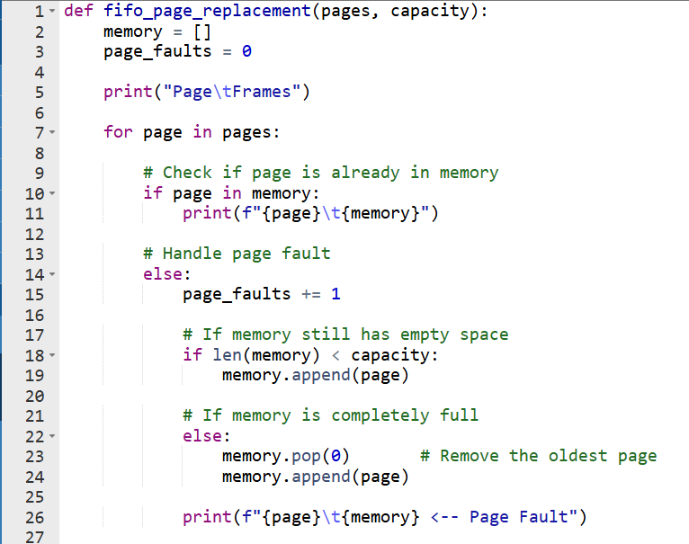

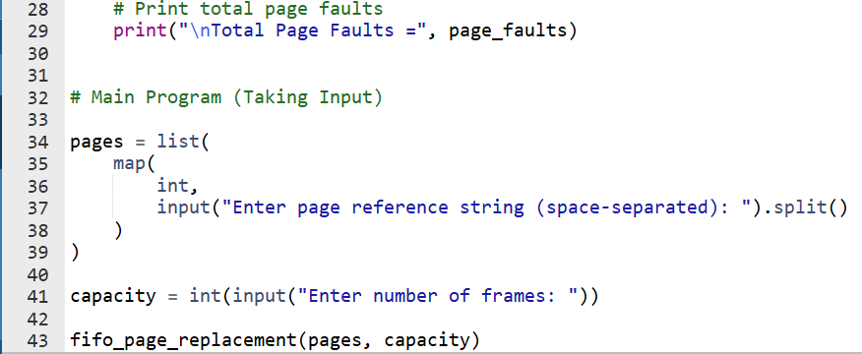

Output :-

